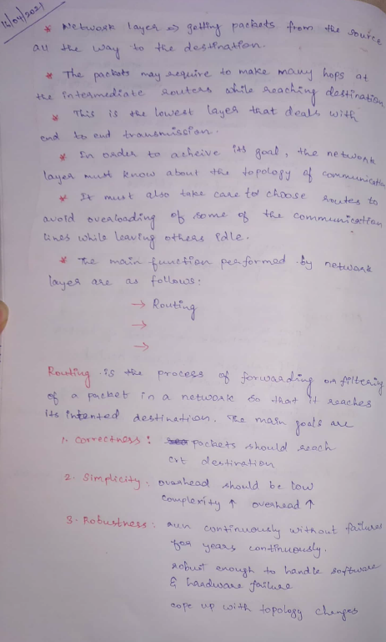 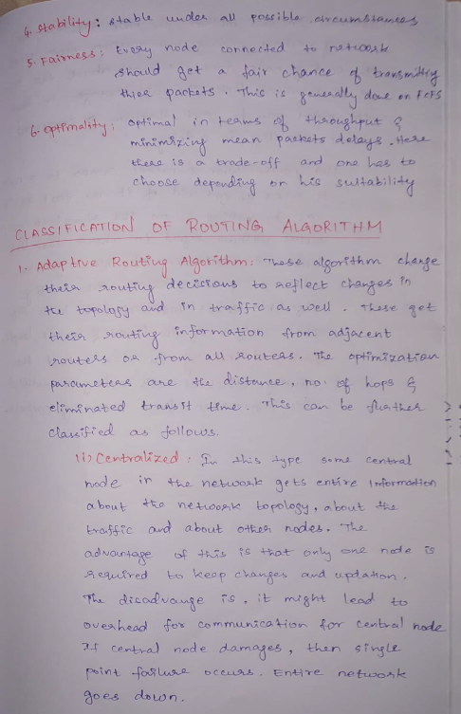

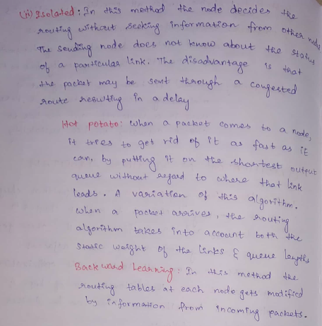

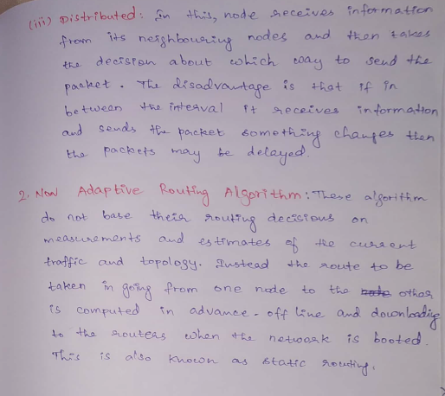

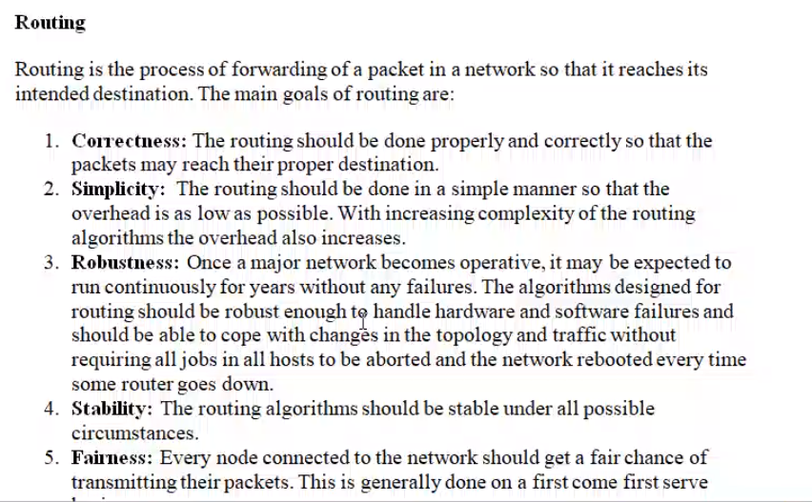

When two nodes (source and destination) are in same network 🡪 filter  
When two nodes (source and destination) are in different network 🡪 forwarding

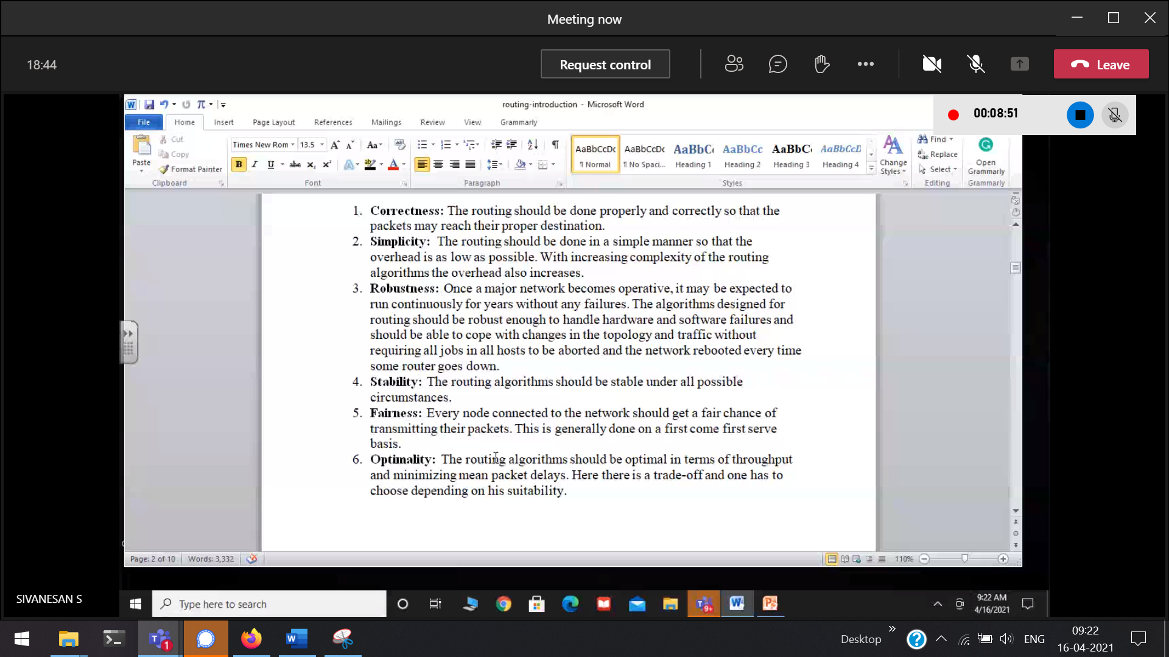

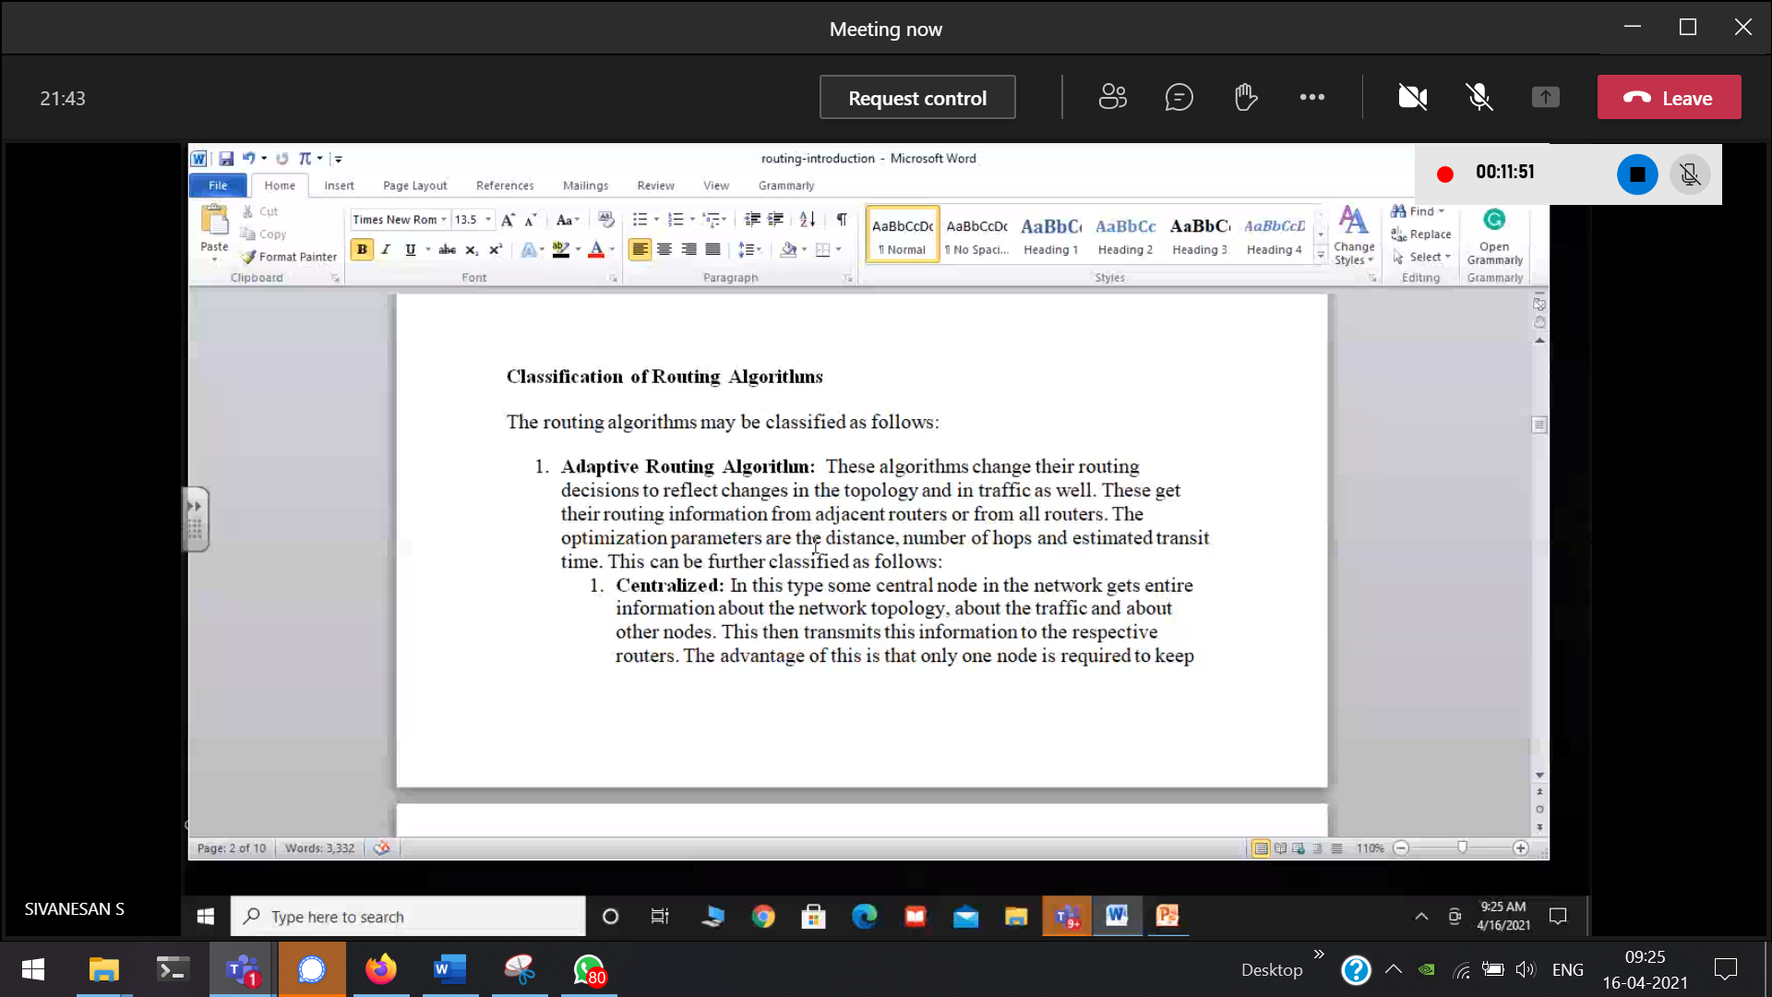

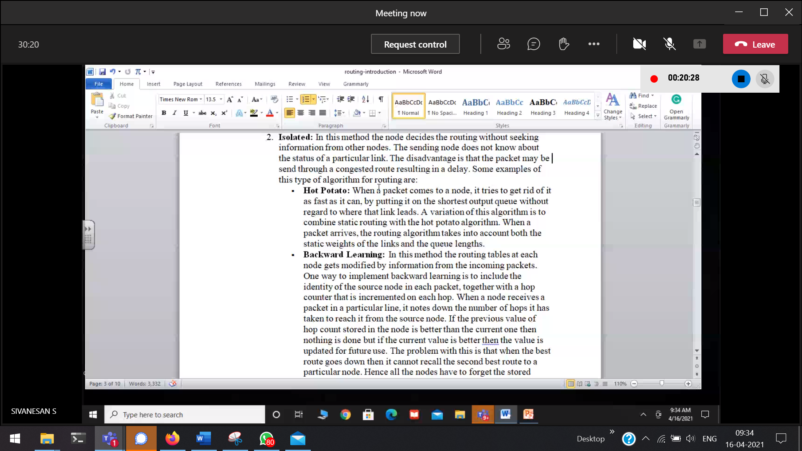

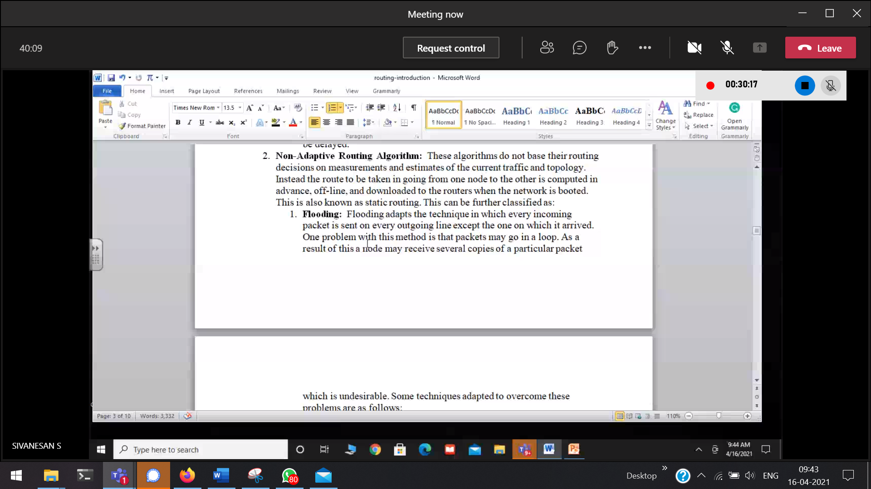

Adaptive 🡪 learning principle is there   
Non-adaptive 🡪 learning principle is not there

# Routing Algorithm

## Direct Delivery

Both the hosts (source and destination) are in the same network. So they do not require any gateway routers(pink cross).

Source to its gateway-router.  
gateway-Router to its Source.  
Both requires Direct Delivery